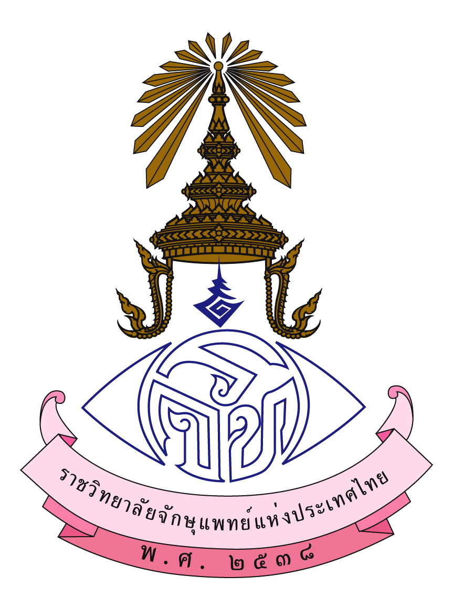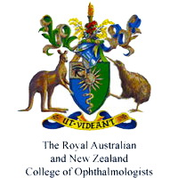

The 3rd Indo-China Ocular inflammations and Infections Meeting
December 9-10, 2014
Hosted by The Royal College Ophthalmologists of Thailand
Sponsored by International Ocular Inflammation Society (IOIS)
and Royal Australian and New Zealand College of Ophthalmologists (RANZCO)
Day 1 - December 9, 2014
8:20-8:30: Introduction and goals of the meeting by
-Dr. Paisan Ruamviboonsuk (Thai Congress Chairman)
- Prof. Narsing A. RAO (President of International Ocular Inflammation Society)
Session 1: Advances in diagnosis and management of infectious ocular inflammations
8:30-10:00: Chairperson and moderator: Nattaporn Tesavibul, Peter McCluskey and RV Paul Chan
(15 minutes/presentation)
- Common uveitis entities in Indo-China/Thailand Pitipol Choopong
- HIV related ocular changes and management during HAART era Kessara Pattanapitoon
- Infectious and Non-infectious conjunctivitis Nattaporn Tesavibul
- Infectious and Non-infectious scleritis Peter McCluskey
- Bacterial endophthalmitis RV. Paul Chan
- Fungal endophthalmitis Dean Eliott
Session 2: Ocular inflammations/Uveitis: Management
10:30-12:00: Chairs and Moderators: Piseth Kong; Jennifer Thorne and May Zun Aung Win
(15 minutes/presentation)
- Terminology and anatomic classification of intraocular inflammation and investigations Manfred Zierhut
- Imaging in uveitis Harvey Uy
- Topical treatment in anterior uveitis and prevention of glaucoma Ann-Marie Lobo
- Systemic corticosteroids and immunosuppressive agents in posterior uveitis: selection, side effects and their prevention Jennifer E. Thorne
- Ocular surface masquerade syndromes Samuel Yiu
- Posterior masquerade syndromes Hiroshi Goto

Session 3: Case presentations on Intraocular infections; Interactive session
13:30-15:00: Chairs and Moderator: Hiroshi Goto; Paul Chan and Pitipol Choopong
(7 minutes presentation and 2 minutes discussion)
Case 1 Pichaporn Artornsombudh(Thailand)
Case 2 Tajunisah Igbal (Malaysia)
Case 3 May Zun Aung Win (Myanmar)
Case 4 Narumon Keorochana (Thailand)
Case5 Khamkhoune Holanouphap(Laos)
Case 6 Fatma Asyari (Indonesia)
Case 7 Shelina (Malaysia)
Case 8 Vietnam
Case 9 Indonesia
Case 10 Rapeeporn Yodprom (Thailand)
Session 4: Intraocular tuberculosis in Indo-China region
15:30-17:00:Chairs and moderator: Tajunisah Igbal, Narsing Rao and Somsiri Sukavatcharin
(15 minutes/presentation)
- Clinical features of intraocular tuberculosis in Indo-China Somsiri Sukavatcharin
- Pathogenesis of intraocular tuberculosis John Gonzales
- Intraocular tuberculosis: Diagnostic support Kalpana Babu Murthy
- Ocular tuberculosis in Bangkok; case presentations Wantanee Sittivarakul
- Sarcoidosis and tuberculosis dilemma in uveitis Aniki Rothova
- Extrapulmonary Tuberculosis; general consideration in diagnosis and treatment Kamon Kawkitinarong
Panel members- Wantanee Sittivarakul (Bangkok); May Zun Aung Win (Myanmar); Tajunisah Igbal (Malaysia);Fatma Asyari (Indonesia) ; Kalpana Babu Murthy (India); Soon Phaik Chee (Singapore); Kamon Kawkitinarong (Bangkok)
December 10, 2014
Session 5: Surgical interventions and Evolving treatments in Intraocular inflammations and uveitis
8:30-10:00: Chairs and Moderators: Mark Humayun; Fatma Asyari and Shwu-Jiuan Sheu
(15 minutes/presentation)
- Surgical management of uveitis related cataract in adults Soon Phaik Chee
- Management of cataract in children with uveitis Jonathan Song
- Ocular toxoplasmosis: local and systemic treatment Supinda Leeamornsiri
- Non-infectious posterior uveitis management with local drug delivery and
intravitreal steroid implant Shwu-Jiuan Sheu
- Evolving local treatments Mark Humayun
- Evolving systemic treatments for posterior uveitis: translational research Manabu Mochizuki
Session 6: Case presentations; interactive session
10:30-12:00: Chairs and Moderators: Soon Phaik Chee, Kalpana Babu Murthy and Manabu Mochizuki
(7 minutes presentation and 2 minutes discussion)
Case 1 Chaisiri Jumroendararasame(Thailand)
Case 2 Wipada Laovirojjanakul (Thailand)
Case 3 Hla Sandar : opthhsd@gmail.com (Myanmar)
Case 4 Zaw Nyein Chan : zawnyeinchan@gmail.com (Myanmar)
Case 5 Olaiphone Panyasavat (Laos)
Case 6 Boontip Tipsuriyaporn (Thailand)
Case 7 Atchara Amphornphruet(Thailand)
Case 8 Cambodia
Case 9 Cambodia
Case 10 Vietnam
Closing remarks and future meeting: Narsing Rao and Somsiri Sukavatcharin

